ASSIGNMENT NO 4

Q1. Given the blocks world indicated in Fig. Solve using Global heuristic function

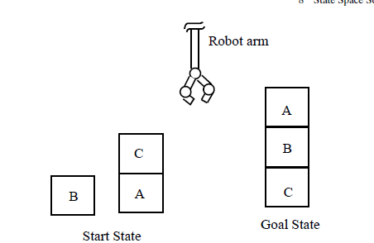

Assume that following rules for moves will be followed by the robot arm for

carrying out this job:

• stack(x, y): stack block x on block y,

• lift(x): lift-up the block x,

• putg(x): put block x on ground,

• unstack(x, y): unstack block x from block y.

Answer:

Initial state:

Block B on ground

Block C on top of block A

Block A on the ground

Goal state:

Block A on top of block B

Block B on top of block C

Block C on ground

Possible moves:

• stack(x, y): stack block x on block y,

• lift(x): lift-up the block x,

• putg(x): put block x on ground,

• unstack(x, y): unstack block x from block y.

Global heuristic function

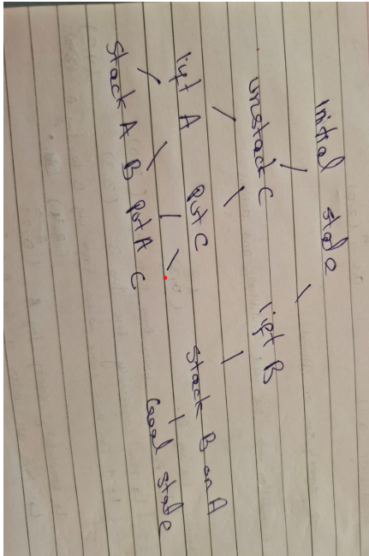

Q2.Solve using A* Algorithm ()

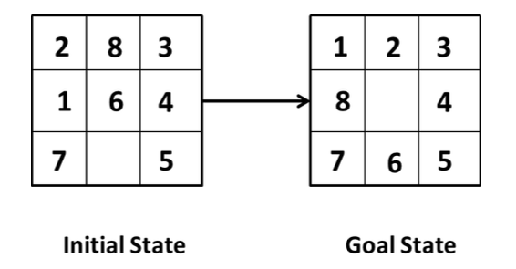

Answer:

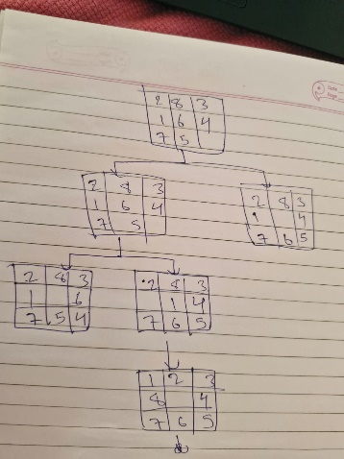

Q3. The map of Romania is given. Start node is Arad and Goal node is Bucharest. Find the optimal path using informed search algorithm.

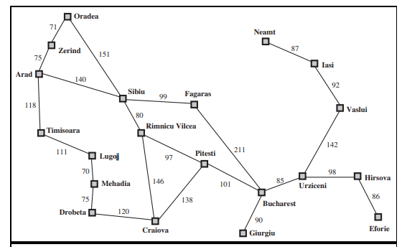

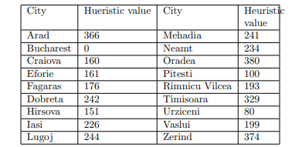

Sibiu 187

Answer:

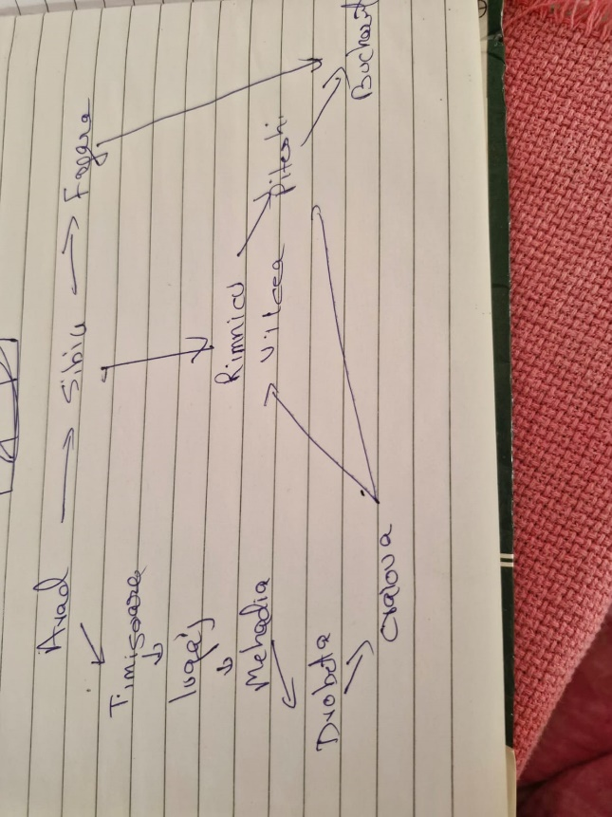

Q4. Solve using hill climbing Algorithm

.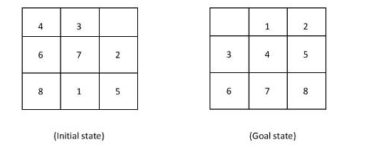

### ****Initial State****

4 3 _

6 7 2

8 1 5

### ****Step 1****: Move ****3**** left

4 _ 3

6 7 2

8 1 5

### ****Step 2****: Move ****4**** down

_ 4 3

6 7 2

8 1 5

### ****Step 3****: Move ****6**** right

6 4 3

_ 7 2

8 1 5

### ****Step 4****: Move ****7**** up

6 4 3

7 _ 2

8 1 5

### ****Step 5****: Move ****2**** left

6 4 3

7 2 _

8 1 5

### ****Step 6****: Move ****5**** up

6 4 3

7 2 5

8 1 _

### ****Step 7****: Move ****1**** right

6 4 3

7 2 5

8 _ 1

### ****Step 8****: Move ****8**** up

6 4 3

7 _ 5

8 2 1

### ****Step 9****: Move ****7**** right

6 4 3

_ 7 5

8 2 1

### ****Step 10****: Move ****6**** down

_ 4 3

6 7 5

8 2 1

### ****Step 11****: Move ****4**** left

4 _ 3

6 7 5

8 2 1

### ****Step 12****: Move ****3**** down

4 3 _

6 7 5

8 2 1

### ****Step 13****: Move ****5**** left

4 3 5

6 7 _

8 2 1

### ****Step 14****: Move ****1**** up

4 3 5

6 7 1

8 2 _

### ****Step 15****: Move ****2**** right

4 3 5

6 7 1

8 _ 2

### ****Step 16****: Move ****8**** up

4 3 5

6 _ 1

8 7 2

### ****Step 17****: Move ****6**** right

4 3 5

_ 6 1

8 7 2

### ****Step 18****: Move ****4**** down

_ 3 5

4 6 1

8 7 2

### ****Step 19****: Move ****3**** left

3 _ 5

4 6 1

8 7 2

### ****Step 20****: Move ****5**** up

3 5 _

4 6 1

8 7 2

### ****Step 21****: Move ****1**** left

3 5 1

4 6 _

8 7 2

### ****Step 22****: Move ****2**** up

3 5 1

4 6 2

8 7 _

### ****Step 23****: Move ****7**** right

3 5 1

4 6 2

8 _ 7

### ****Step 24****: Move ****8**** up

3 5 1

4 _ 2

8 6 7

### ****Step 25****: Move ****4**** right

3 5 1

_ 4 2

8 6 7

### ****Step 26****: Move ****3**** down

_ 5 1

3 4 2

8 6 7

### ****Step 27****: Move ****5**** left

5 _ 1

3 4 2

8 6 7

### ****Step 28****: Move ****1**** up

5 1 _

3 4 2

8 6 7

### ****Step 29****: Move ****2**** left

5 1 2

3 4 _

8 6 7

### ****Step 30****: Move ****7**** up

5 1 2

3 4 7

8 6 _

### ****Step 31****: Move ****6**** right

5 1 2

3 4 7

8 _ 6

### ****Step 32****: Move ****8**** up

5 1 2

3 4 7

_ 8 6

### ****Step 33****: Move ****5**** down

_ 1 2

5 4 7

3 8 6

### ****Step 34****: Move ****1**** left

1 _ 2

5 4 7

3 8 6

### ****Step 35****: Move ****2**** left

CopyEdit

1 2 _

5 4 7

3 8 6

### ****Step 36****: Move ****7**** up

1 2 7

5 4 _

3 8 6

### ****Step 37****: Move ****6**** right

1 2 7

5 4 6

3 8 _

### ****Step 38****: Move ****8**** up

1 2 7

5 4 6

_ 8 3

### ****Step 39****: Move ****5**** down

1 2 7

_ 4 6

5 8 3

### ****Step 40****: Move ****4**** left

1 2 7

4 _ 6

5 8 3

### ****Step 41****: Move ****6**** up

1 2 7

4 6 _

5 8 3

### ****Step 42****: Move ****3**** left

1 2 7

4 6 3

5 8 _

### ****Step 43****: Move ****8**** up

1 2 7

4 6 3

5 _ 8

### ****Step 44****: Move ****5**** right

1 2 7

4 6 3

_ 5 8